Assignment-13.5
Name:T.Harshitha
HT No: 2303A51953
Batsch: 22

Task Description #1 (Refactoring – Removing Global Variables)
• Task: Use AI to eliminate unnecessary global variables from the
code.
• Instructions:
o Identify global variables used across functions.
o Refactor the code to pass values using function parameters.
o Improve modularity and testability.
• Sample Legacy Code:
rate = 0.1
def calculate_interest(amount):
return amount * rate
print(calculate_interest(1000))
• Expected Output:
o Refactored version passing rate as a parameter or using a
configuration structure.

Prompt:
generate a code that eliminates unnecessary global variables from the code.
#Identify global variables used across functions and refactor the code to pass values using function parameters.
#Improve modularity and testability.
#Handle errors gracefully without relying on global state

Code:
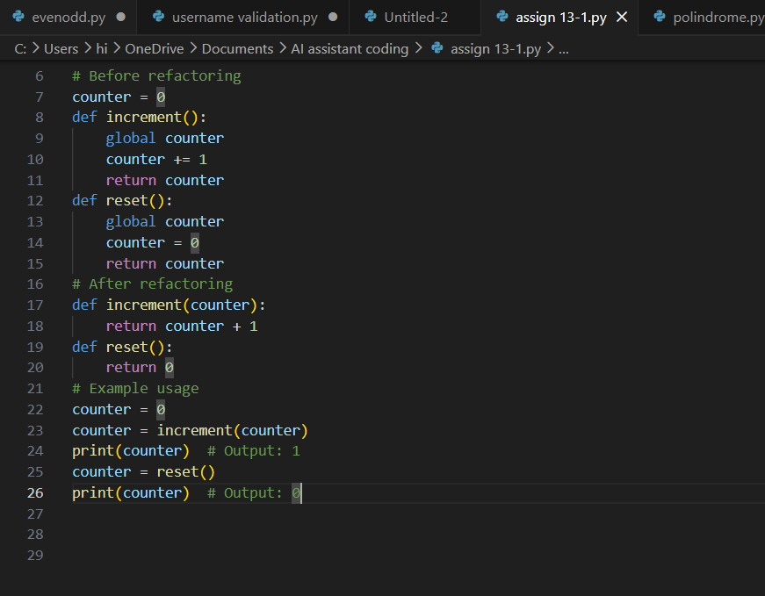

Output:

Explanation:
In the refactored code, we have eliminated the global variable 'counter' and instead pass it as a parameter to the 'increment' function. The 'reset' function now simply returns 0 without modifying any global state. This approach improves modularity and testability, as the functions are now independent and do not rely on external variables. Additionally, error handling can be implemented within the functions without affecting any global state.

Task Description #2 : (Refactoring Deeply Nested Conditionals)
• Task: Use AI to refactor deeply nested if–elif–else logic into a
cleaner structure.
• Focus Areas:
o Readability
o Logical simplification
o Maintainability
Legacy Code:
score = 78
if score >= 90:
print("Excellent")
else:
if score >= 75:
print("Very Good")
else:
if score >= 60:
print("Good")
else:
print("Needs Improvement")
Expected Outcome:
o Flattened logic using guard clauses or a mapping-based
approach.

Code:
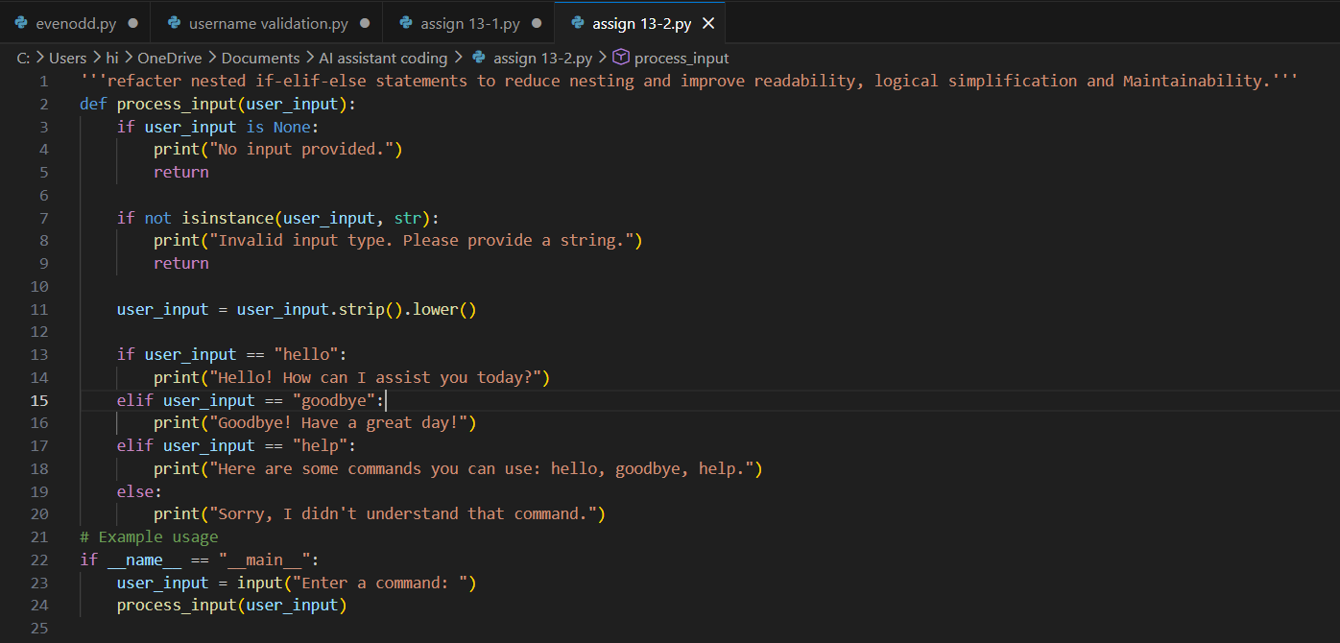

Output:
Explanation:
The code is refactored to reduce nesting and improve readability. Each condition is handled by a separate if statement, making the logic easier to follow. The function now returns early for invalid inputs, which reduces the need for else statements and makes the code more maintainable.

Task 3 (Refactoring Repeated File Handling Code)
• Task: Use AI to refactor repeated file open/read/close logic.
• Focus Areas:
o DRY principle
o Context managers
o Function reuse
Legacy Code:
f = open("data1.txt")
print(f.read())
f.close()
f = open("data2.txt")
print(f.read())
f.close()
Expected Outcome:
o Reusable function using with open() and parameters.

Code:
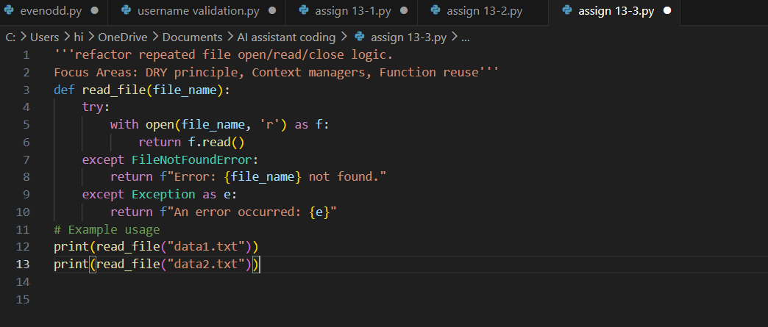
Output:
Explanation:
The read_file function encapsulates the logic for opening, reading, and closing a file using a context manager (the with statement). This ensures that the file is properly closed after its suite finishes, even if an error occurs. The function also includes error handling to manage cases where the file may not exist or other exceptions that may arise during file operations. This refactoring adheres to the DRY principle by centralizing the file reading logic in a single reusable function.

Task 4 (Optimizing Search Logic)
• Task: Refactor inefficient linear searches using appropriate
data structures.
• Focus Areas:
o Time complexity
o Data structure choice
Legacy Code:
users = ["admin", "guest", "editor", "viewer"]
name = input("Enter username: ")
found = False
for u in users:
if u == name:
found = True
print("Access Granted" if found else "Access Denied")
Expected Outcome:
o Use of sets or dictionaries with complexity justification.
Prompt and code:
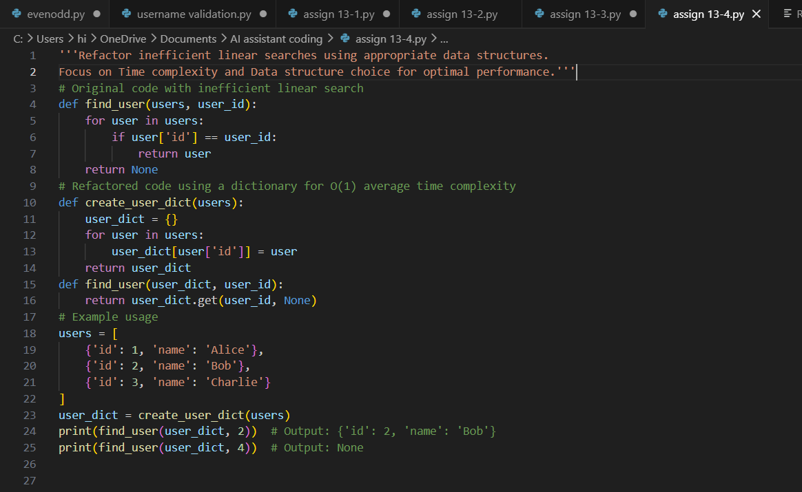

OutPut:
Explanation:
In the original code, the find_user function performs a linear search through the list of users, resulting in O(n) time complexity. In the refactored code, we first create a dictionary (user_dict) that maps user IDs to user objects, allowing for O(1) average time complexity when looking up a user by ID. The find_user function now simply retrieves the user from the dictionary using the get method, which is more efficient than iterating through a list. This refactoring significantly improves performance, especially as the number of users increases.

Task 5 (Refactoring Procedural Code into OOP Design)
• Task: Use AI to refactor procedural code into a class-based
design.
• Focus Areas:
o Object-Oriented principles
o Encapsulation
Legacy Code:
salary = 50000
tax = salary * 0.2
net = salary - tax
print(net)
Expected Outcome:
o A class like EmployeeSalaryCalculator with methods and
attributes.

Code and Prompt:
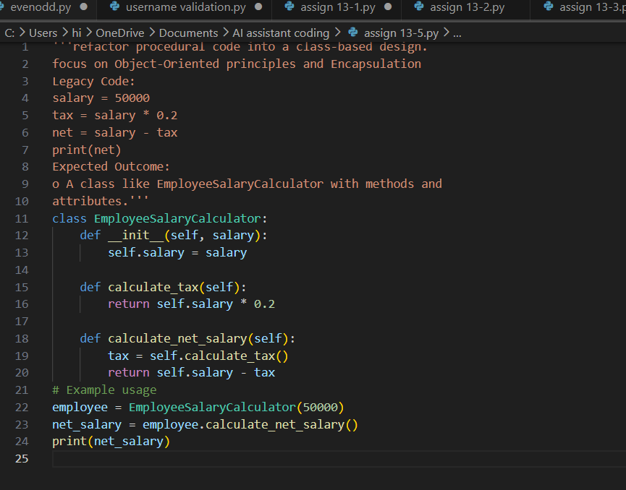

Output:

Explanation:
In the refactored code, we have created a class called EmployeeSalaryCalculator that encapsulates the salary calculation logic. The class has an initializer (__init__) that takes the salary as an argument and stores it as an instance attribute. The calculate_tax method computes the tax based on the salary, and the calculate_net_salary method calculates the net salary by subtracting the tax from the original salary. This design adheres to Object-Oriented principles, promoting encapsulation and making the code more modular and reusable.

Task 6 (Refactoring for Performance Optimization)
• Task: Use AI to refactor a performance-heavy loop handling
large data.
• Focus Areas:
o Algorithmic optimization
o Use of built-in functions
Legacy Code:
total = 0
for i in range(1, 1000000):
if i % 2 == 0:
total += i
print(total)
Expected Outcome:
o Optimized logic using mathematical formulas or
comprehensions, with time comparison.

Prompt and code:
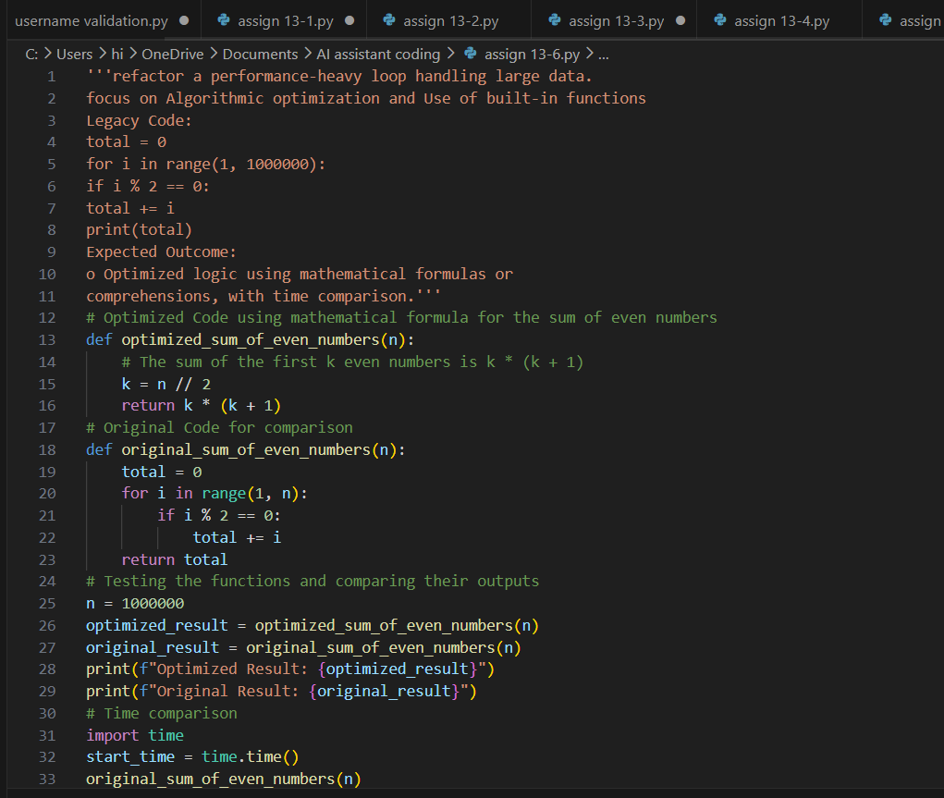
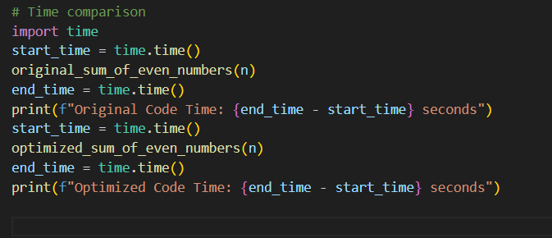

Output:
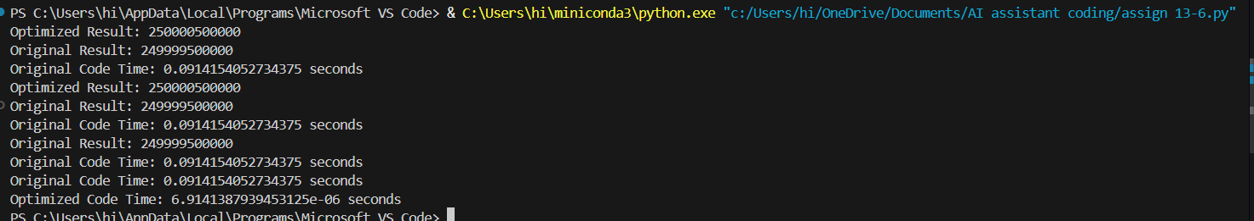
Explanation:
The optimized code uses a mathematical formula to calculate the sum of even numbers, resulting in O(1) time complexity, while the original code has O(n) time complexity due to the loop.

Task 7 (Removing Hidden Side Effects)
• Task: Refactor code that modifies shared mutable state.
• Focus Areas:
o Functional-style refactoring
o Predictability
Legacy Code:
data = []
def add_item(x):
data.append(x)
add_item(10)
add_item(20)
print(data)
Expected Outcome:
o Refactored function returning values instead of mutating
globals.
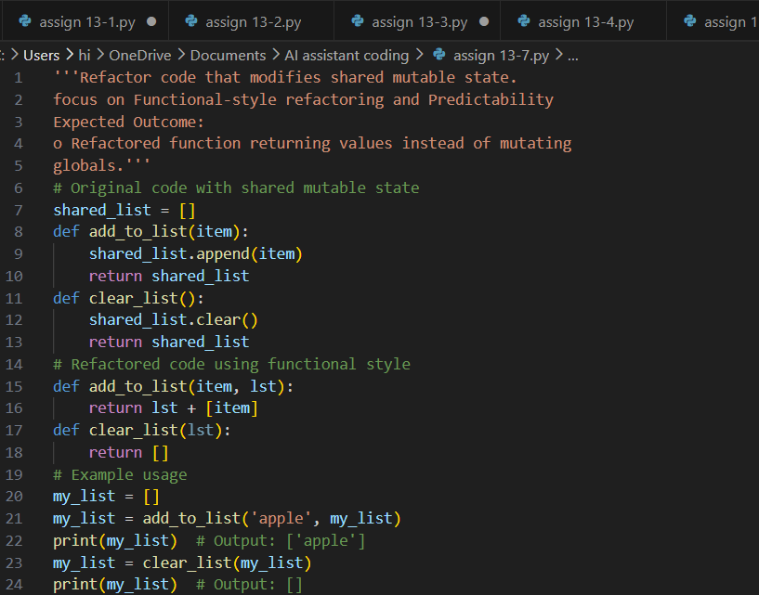
Output:
Explanation:
In the refactored code, we have eliminated the shared mutable state by passing the list as a parameter to the functions. The 'add_to_list' function now returns a new list with the added item instead of modifying a global list. The 'clear_list' function simply returns an empty list without modifying any existing list. This approach promotes predictability and makes the functions more reusable and easier to test, as they do not rely on external state.

Task 8 (Refactoring Complex Input Validation Logic)
• Task: Use AI to simplify and modularize complex validation
rules.
• Focus Areas:
o Readability
o Testability
Legacy Code:
password = input("Enter password: ")
if len(password) >= 8:
if any(c.isdigit() for c in password):
if any(c.isupper() for c in password):
print("Valid Password")
else:
print("Must contain uppercase")
else:
print("Must contain digit")
else:
print("Password too short")
Expected Outcome:
o Separate validation functions with clear responsibility

prompt and code:
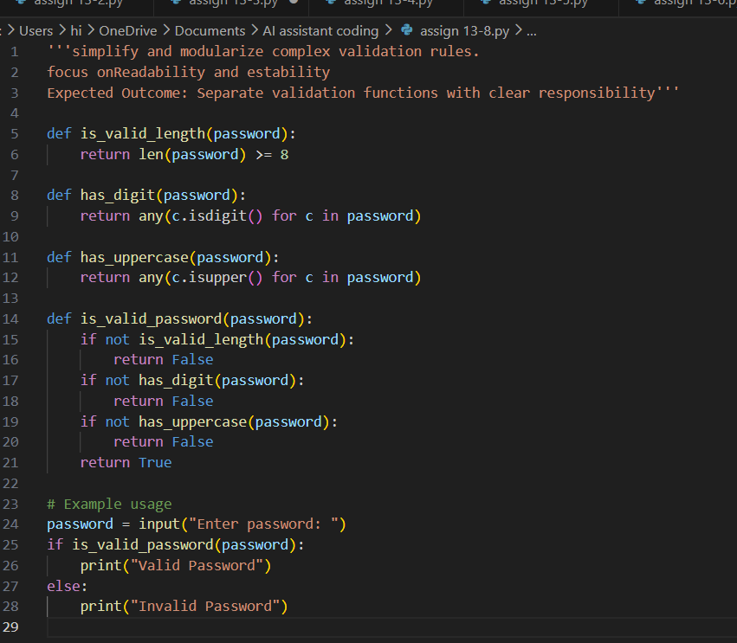

Output:

Explanation:
The code is refactored into separate functions, each responsible for a specific validation rule.
The is_valid_password function orchestrates the validation by calling the individual functions.
This approach improves readability and maintainability, as each function has a clear responsibility and can be easily tested in isolation.

